Reading and Reasoning in Mathematics

Steps to Success

Reading and Reasoning Process

First Read: Read for Understanding

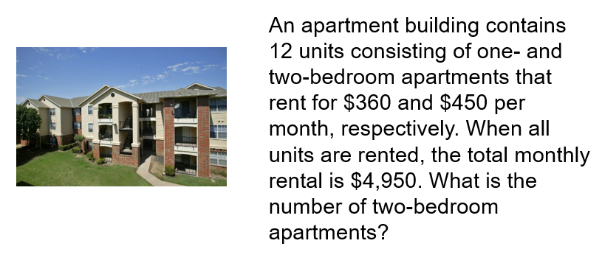

Tiered Vocabulary

Frayer Model

Second Read – Noticing and Wondering

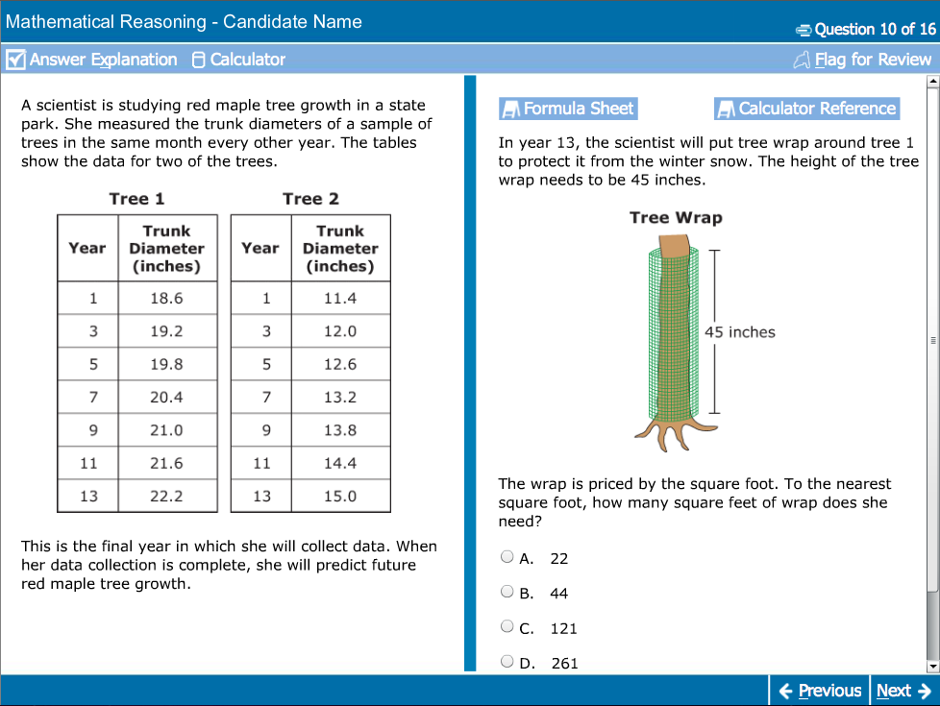

What do you wonder?
What do you notice?

Must Have Heuristics – Thinking Strategies
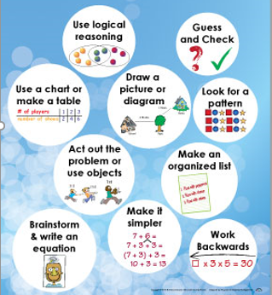

Guess and Check

Copy the figure below and place the digits 1, 2, 3, 4, and 5 in the circles so that sums across (horizontally) and down (vertically) are the same.

Make a List

Three darts hit this dart board and each scores a 1, 5, or 10. The total score is the sum of the scores for the three darts. There could be three 1’s, two 1’s and one 5, one 5 and two 10’s, and so on. How many different possible total scores could a person get with three darts?

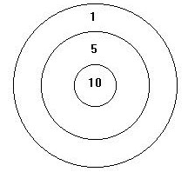

Draw a Diagram

In a stock car race, the first five finishers in some order were a Ford, a Pontiac, a Chevrolet, a Buick, and a Dodge.
- The Ford finished seven seconds before the Chevrolet.
- The Pontiac finished six seconds after the Buick.
- The Dodge finished eight seconds after the Buick.
- The Chevrolet finished two seconds before the Pontiac.
In what order did the cars finish the race? What strategy did you use?

Make a Table or Chart

South Point Amusement Park has a special package for large groups: a flat fee of $20 and $6 per person.

If a club has $100 to spend on admission, what is the largest number of people who can attend?

Find a Pattern

Continue these numerical sequences by finding the next three numbers for each group.

1, 4, 7, 10, 13, ___, ___, ___

19, 20, 22, 25, 29, ___, ___, ___

2, 6, 18, 54, ___, ___, ___

Make it Simpler

The houses on Main Street are numbered consecutively from 1 to 150.

How many house numbers contain at least one digit 7?

Act It Out or Use Objects

The figure shows twelve toothpicks arranged to form three squares. How can you form five squares by moving only three toothpicks?

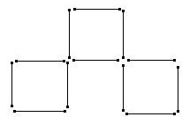

Work Backwards

Brady was trying to decide when to get up in the morning. He needs 45 minutes to get ready for the workshop he plans to attend. It takes him 25 minutes to drive to the adult center where the workshop will be held. He wanted to get to center 20 minutes early to stop by his classroom and pick up some materials. If the session starts at 7:30, what time should he get up, if he wants to give himself 10 extra minutes in case the traffic is bad?

Brainstorm and Write an Equation

Two apples weigh the same as a banana and a cherry. A banana weighs the same as nine cherries. How many cherries weigh the same as one apple?

Use Logical Reasoning

Three apples and two pears cost 78 cents. But two apples and three pears cost 82 cents. What is the total cost of one apple and one pear?

Problem Solving Graphic Organizer – Goals and Givens
PROBLEM SOLVING TEMPLATE: This template can be used as another tool that will develop the process of goals and givens. Students will still have multiple reads of the content to complete this template.

Goal: What is the question? | Givens: Important details/information that is provided

Plan: What strategies will you use? May have multiple checked.
Draw and Label Diagram/Picture
Guess and Check
Make it simpler
Look for patterns
Make a table
Act out of use objects
Write an equation
Work backwards
Other
Circle the one that was most effective.

Conjecture: (reasonable guess)
Predict your answer and any reasoning that results in your predicted answer
Solution: (make no assumptions, label everything)

Solution: Persevere – if one strategy doesn’t work try another one.

Answer: Write a complete sentence that answers your goal with appropriate units.

Verification: Explain why your answer makes sense. Why is it reasonable? Did you answer the goal? Is there another strategy that proves your answer is correct?

Scoring Rubric
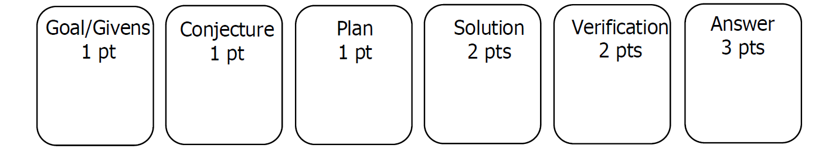

Goals and Givens – It’s Your Turn!
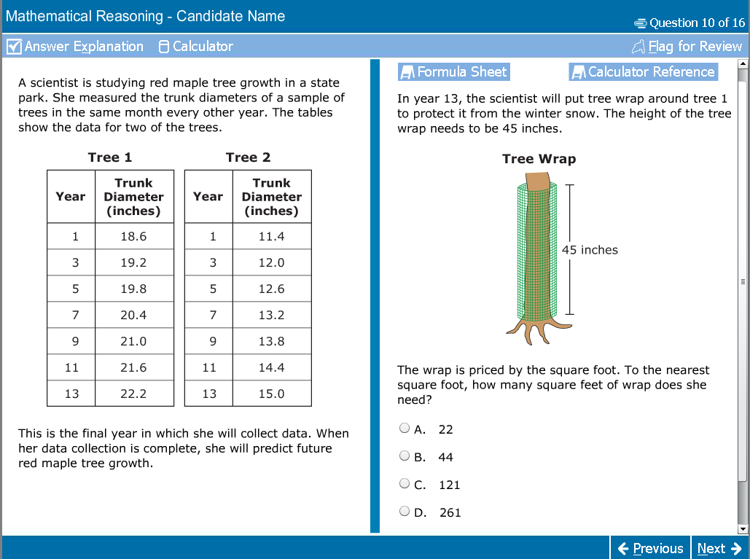

Goal: What is the question? | Givens: Important details/information that is provided
Plan: What strategies will you use? May have multiple checked.
Draw and Label Diagram/Picture
Guess and Check
Make it simpler
Look for patterns
Make a table
Act out of use objects
Write an equation
Work backwards
Other

Conjecture: (reasonable guess)
Predict your answer and any reasoning that results in your predicted answer
Solution: (make no assumptions, label everything)

Solution: Persevere – if one strategy doesn’t work try another one.

Answer: Write a complete sentence that answers your goal with appropriate units.

Verification: Explain why your answer makes sense. Why is it reasonable? Did you answer the goal? Is there another strategy that proves your answer is correct?

Quick Draw

